

**Attract For Commercial Drivers Underwriting Non-FCRA**

**Quickbase #1483**

**Product Market Requirements (PMR) Document**

Version 1.4

**CONFIDENTIAL & PROPRIETARY**

The recipient of this material (hereinafter “the Material”) acknowledges that it contains confidential and proprietary data the disclosure to, or use of which by, third parties will be damaging to LexisNexis Inc and its affiliated companies (hereinafter “LexisNexis”). Therefore, recipient agrees to hold the Material in strictest confidence, not to make use of it other than for the purpose for which it is being provided, to release it only to employees requiring such information, and not to release or disclose it to any other party. Upon request, recipient will return the Material together with all copies and modifications, if any.

All names in the text, or on the sample reports and screens shown in this document, are of fictitious persons and entities. Any similarity to the name of any real person, address, school, business or other entity is purely coincidental.

The trademarks, logos, and service marks (collective the “Marks” or “Mark”) appearing in this document are registered and unregistered Marks of LexisNexis and others. The information contained herein does not constitute a grant of any license or right to use any Mark displayed on this document. LexisNexis aggressively enforces its intellectual property rights.

**TABLE OF CONTENTS**

1. Documentation Revision History 4

2. Documentation Guidelines 4

3. Key Contacts 5

4. Vertical Market 5

5. Target Implementation Date/Quarter 5

6. Initiative Purpose 5

7. Dependencies 6

8. Product/Service Requirements 6

9. Contributory Requirements 12

10. Rule Plan Requirements 12

11. Modeling Requirements 12

12. Third Party Data and Vendor Requirements 13

13. Volume 13

14. MBSi Requirements – TBD Account Setup 13

15. Support Tool 14

16. Management Reports 14

17. Consumer Disclosure 14

18. Billing 14

19. Testing 15

20. Legal 15

21. Security Assessment 15

22. Sales Tax 15

23. Appendix A – Rules Functional Specifications 16

24. Appendix B – MBSi Screens 16

24. Appendix B – Modeling Document 16

1. Documentation Revision History

|  |  |  |  |
| --- | --- | --- | --- |
| **Version** | **Date** | **Author** | **Remarks/Comments** |
| 1.0 | 09-15-13 | Connie Fitzsimmons | First draft. |
| 1.1 | 11-01-13 | Connie Fitzsimmons | Updates after first PMR review 10-29-13 with account setup, MVR clarification re: DHDB/DUP, no reason codes/model indicators, model inquiry and data attributes. |
| 1.2 | 11-26-13 | Connie Fitzsimmons | Added Account Setup (f.k.a MBSi Requirements), and renumbered the other changes. |
| 1.3 | 12-09-13` | Connie Fitzsimmons | Updates after discussion with the Vertical and MBSi Teams. |
| 1.4 | 12-12-13 | Connie Fitzsimmons | Added 2 score model ids. |
| Baseline |  |  | Baseline Document Completed |
| **Change Request** |  |  |  |
| CR1 |  |  |  |
| CR2 |  |  |  |
| CR3 |  |  |  |

1. Documentation Guidelines

|  |  |
| --- | --- |
| **Document**  **Author** | This originates from the market vertical team and expanded on by the Product Manager or New Product Execution team member. |
| **Document Purpose** | The document defines purpose, requested product solution functionality, exceptions, performance requirements, legal and regulatory compliances, and operational requirements. |
| **Document Audience** | The Technology and *Rules Business Analyst teams will use this document to determine the system and technical specifications. |
| **Expected Outcome** | Ensure a common understanding among the project delivery team, of the market problem being solved and the proposed solution. |
| **Document Reviewer** | Market Vertical, Technical Design teams, and the appropriate operational stakeholders. Refer to the [Product Release Checklist](http://teamsites.choicepoint.net/insurance/pncmkt/pmm/Templates/Prod%20Dev%20-%20Product%20Release%20Checklist/Product%20Release%20Checklist%20-%20RACI.xls) for a complete list. |
| **Document Approver** | Document must be approved by Technical and Market Vertical teams to ensure all Vertical requirements are met and clearly enunciated. |
| **Document Destination** | New Product Execution Team SharePoint document repository. |
| **Additional**  **Helpful Tips** | Additional requirements and approvals may be required if other groups such as Rules Business Analysts and Modeling Analytics are affected.  This document may contain more headings/categories than applicable for your product solution. Simply indicate NA-Not Applicable, to illustrate that all areas were proactively considered. |

1. Key Contacts

|  |  |  |
| --- | --- | --- |
| **Name** | **Title** | **Responsibility** |
| Mathew Stordy  Hemi Patel | Business Vertical | Responsible for defining product/solution concept based on needs and requirements from the market. |
| Connie Fitzsimmons Susan Goss | New Product Execution | Responsible for defining the business requirements for the initiative. |
| Aaron Hale | Product Management | Responsible for managing the initiative once in production. |
| Ben Saunders | Engineering Project Management | Responsible for the project schedule and coordination of development, testing and production implementation. |
| Rajesh Talreja | Development | Responsible for the design, development and implementation of the initiative into the LN infrastructure. |
| Scott Goss  Matthew Rutland | Rules Business Analyst | Responsible for the Rules functional specifications for integration into the implementation. |
| Dimple Patel | Model Office Testing | Responsible for testing using the Rules functional specifications for integration into the implementation. |
| Becky Champion | Modeling | Responsible for defining and creating the model which will be used for initiative. |
| Nancy O’neill | Customer Test | Responsible for developing appropriate customer test cases. |
| Juan Londono | QC | Responsible for testing system and application functionality as outlined in the PMR. |
| Chris Tolbert/Adrienne Peek | MBSi | Responsible for development of account setup, product configuration, billing, support tool, management reports and consumer disclosure. |

1. Vertical Market – Commercial
2. Target Implementation Date/Quarter– Q1 2014
3. Initiative Purpose
   1. **Executive Summary** – For the purposes of rating, Commercial insurers who write small to mid-size fleets traditionally collect detailed information related to the vehicles in the fleet. For many insurers, limited driver information such as years of experience, years employed, and age are used in policy rating. Insurers also pull MVR’s on individual drivers and charge for violations and accidents.

Commercial insurers desire to gather more detailed information on fleet drivers. This includes driver class (age, gender, and marital status), violation and accident history, credit, and other personal attributes predictive of the risk of loss.

Due to FCRA considerations, it is not a common practice for insurers to order credit-based insurance scores for individual drivers to evaluate fleet risks. However, the need to evaluate each driver’s performance with credit-like attributes exists in the marketplace.

* 1. **Market Opportunity** – As the use of FCRA/Credit data in commercial underwriting comes under scrutiny, LexisNexis needs to develop a risk score sourced off of public records and other Non-FCRA data assets.  This score will be utilized when underwriting drivers (commercial auto).
  2. **Financial Objective** –
     1. Year 1 = $200,000.00
     2. Year 2 = $500,000.00
     3. Year 3 = $750,000.00

1. Dependencies
   1. **Assumptions** – Assumes Analytics Team will have the Model completed. Model is complete.

Accounts will need to be setup with SVC, no CSC.

Accounts will not be setup with DHDB, DUP or Activity files.

 We are not making any changes to MVR and the way the product is processed today**.**

* 1. **Issues** – NA
  2. **Constraints** – NA

1. Product/Service Requirements
   1. **Overview** –

The Modeling Team will develop a risk score sourced off of public records.

There will be two versions of the Attract for Commercial Driver Underwriting model.  One version that includes MVR attributes and a second version that excludes MVR attributes. The score and model will be Non-FCRA.  Additional non-FCRA data sources may be added at a later time pursuant to additional PIR requests.    
  
Two models will be built. One model will include Public Record attributes, NO MVRDUP and DHDB data or Activity files can be used. This model will exclude MVR attributes. A second model will include Public Record and MVR attributes. MVR is considered Non-FCRA because the carrier is ordering on a fleet.  
  
The order from the customer will be the same as used to order an MVR.  The customer inquiry will need Data Enhancement (such as address) to obtain missing information needed for the order to public records.  The inquiry will be in the MVR or XML format. The LexID (Modeling is checking on the use of this.) for each driver will be used to append the appropriate Public Record and other attributes (depending on which version of model is used) to be consumed by the model to develop the score ~~and reason codes.~~ 

A rule plan will enhance the inquiry data by ordering Data Enhancement and send results to ISS with or without the MVR. Carrier will determine model to be ordered. Rule plan will be setup to force the MVR order to the DMV. MVR and score results will be separate product results. Additional details will be in the Rules Functional Requirements Specifications (FRS).

The model will produce a score for each driver from 200 to 997, where 200 = highest (worst) risk, 997 = lowest (best) risk, etc. reason codes for each driver describing which attributes (or lack thereof) contributed to the score.      The lists of reason codes are TBD. There will not be reason codes/model indicators.

* 1. **Data** – The Attract for Commercial Drivers will utilize data attributes from:
* Boca Shell 4.0 (Public Records)
* Motor Vehicle Reports (MVR’s)

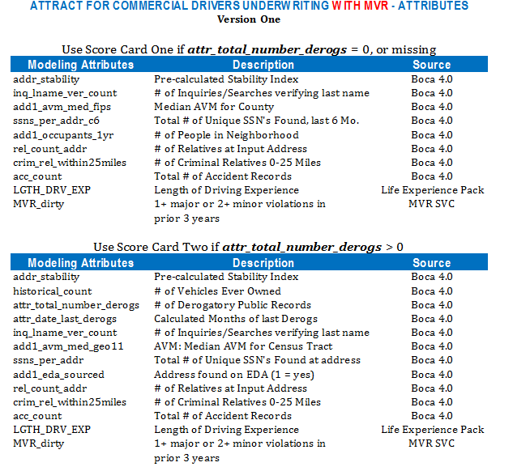7

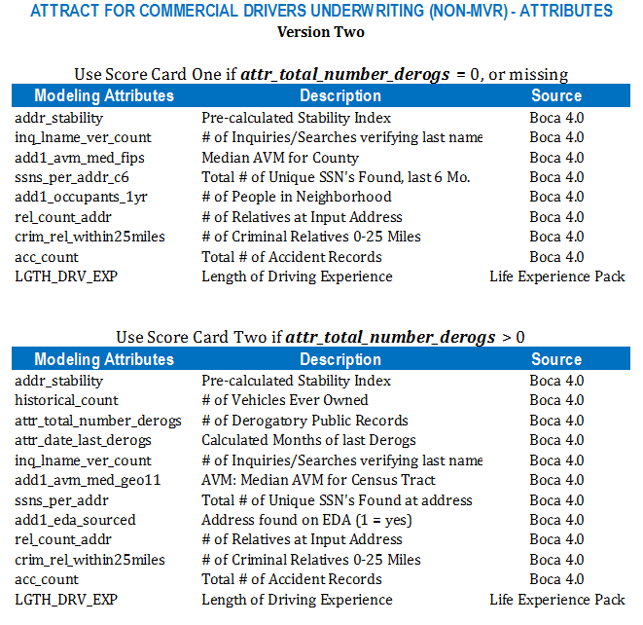

* 1. **Compliance/Restrictions** – DPPA, GLB

The defaults for Insurance, approved by legal are:

The DPPA code to be logged is “6” – For use by an insurer or insurance support organization, or by a self-insured entity, or its agents, employees, or contractors, in connection with claims investigation activities, antifraud activities, rating or underwriting.

The GLB code to be logged is “1” – As necessary to effect, administer, or enforce a transaction that a consumer requests or authorizes.

. **We are not making any changes to MVR and the way the product is processed today.**

* 1. **Contract Restrictions:** Customer level contracts to include GLB / DPPA language. MVR restrictions will be listed in the contract.
  2. **Interface** – Interactive (Batch for MVR result will be detailed in the Rules FRS)
  3. **Delivery System** – System-to-system

Insurance Solutions portal will be implemented at a later date.

* 1. **Process Flow** –



* 1. **Format** – MVR Inform v1/v2 and XML
  2. **Inquiry** – MVR fields vary by state.
* First and last name - Required
* DL # - Required
* DOB - Optional
* SSN- Optional
* Address- Optional
  1. **Result** – Score and Reason Codes and/or MVR

Data Enhancement result with missing data from the inquiry, will be sent back to the carrier. Vertical is checking with Legal on the details.

* 1. **Standard Common Status Codes** – Standard list of Processing, Error and Billing status codes.

| **Internal or External to Customer** | **Message Code** | **XML/HPCC Common Processing Status Code** | **XML/HPCC Common Order Status Code  (to bill or not bill the order in MBSi)** | **Score Server Message (Internal)** | **Customer Message (External)** |
| --- | --- | --- | --- | --- | --- |
| Internal | Empty |  | 100 | Regular order is ready to bill |  |
| Internal | Empty |  | 101 | Regular order has been billed |  |
| Internal | Empty |  | 102 | Dupe/Secondary order ready to bill |  |
| Internal | Empty |  | 103 | Dupe/Secondary order has been billed |  |
| Internal | Empty |  | 104 | Attachment is ready to bill |  |
| Internal | Empty |  | 105 | Attachment has been billed |  |
| Internal | Empty |  | 199 | Error during billing |  |
| Internal | Empty |  | 201 | Order has processed successfully but is not billed |  |
| Internal | Empty |  | 205 | OPR transactions on hold |  |
| External | Empty | 301 | 301 | STF generated by the application | Product Unavailable. Please call LexisNexis at 1-800-236-9993. |
| External | Empty | 302 | 302 | STF generated by the Roxie | Product Unavailable. Please call LexisNexis at 1-800-236-9993. |
| External | Empty | 303 | 303 | STF generated by the ESP (application unreachable) | Product Unavailable. Please call LexisNexis at 1-800-236-9993. |
| External | Empty | 304 | 304 | STF generated by the ESP (timeout waiting on response) | Product Unavailable. Please call LexisNexis at 1-800-236-9993. |
| External | Empty | 305 | 305 | STF generated by the ESP (connection lost to host) | Product Unavailable. Please call LexisNexis at 1-800-236-9993. |
| External | Empty | 401 | 401 | Insufficient Search Data | Incomplete Data In Order. Please call LexisNexis at 1-800-236-9993 |
| External | Empty | 402 | 402 | Invalid Account or Node ID | Incomplete Data In Order. Please call LexisNexis at 1-800-236-9993 |
| External | Empty | 403 | 403 | Error Received from Third Party Vendor | Internal Product Error. Please call LexisNexis at 1-800-236-9993. |
| External | Empty | 404 | 404 | Score Unavailable at this time | Internal Product Error. Please call LexisNexis at 1-800-236-9993. |
| External | Empty | 405 | 405 | Black listed URL | Internal Product Error. Please call LexisNexis at 1-800-236-9993. |
| External | Empty | 406 | 406 | State Affidavit not on file | Internal Product Error. Please call LexisNexis at 1-800-236-9993. |
| External | Empty | 407 | 407 | Invalid Data. Model ID (PXXX)Found in Record | Incomplete Data In Order. Please call LexisNexis at 1-800-236-9993 |
| External | Empty | 408 | 408 | Vendor Unavailable | Internal Product Error. Please call LexisNexis at 1-800-236-9993. |
| External | Empty | 409 | 409 | State Unavailable | Internal Product Error. Please call LexisNexis at 1-800-236-9993. |
| External | Empty | 410 | 410 | All products ordered received errors | Internal Product Error. Please call LexisNexis at 1-800-236-9993. |
| External | Empty | 411 | 411 | Unable to bill. Required fields missing. | Internal Product Error. Please call LexisNexis at 1-800-236-9993. |
| External | Empty | 499 | 499 | Application Unreachable (PROD_MF_SWITCH)   No Response - Timeout (PROD_MF_SWTCH)   Inquiry Records are Missing or Invald  Edits Conversion Error : V2 TO V1   Missing Sidex Trailer Record  Missing Sidex Header Record  Fatal API Error  Received HTTP get on Sidex Port  Received HTTP Post On Sidex Port | Product Unavailable. Please call LexisNexis at 1-800-236-9993 |
| External | Empty | 501 |  | Complete | Results specific to product |
| External | 60 | 503 |  | Not Found | Specific to product |
| External | 80 | 504 |  | No Score | Specific to product |
| External | 50 | 504 |  | No Score | Specific to product |
| External | 10 | 504 |  | Subject Deceased Indicator | Specific to product |

1. Contributory Requirements **–** N/A
2. Rule Plan Requirements **–** Yes – TBD - FRS
   1. See Appendix for Rules Functional Specifications
      1. Details provided by Rules Business Analyst
3. **Modeling Requirements** – Refer to the Analytics/Modeling Group
   1. Details provided by the Modeling team.
   2. Score model ids –

C114 – Commercial Driver Model, Public Records

C115 – Commercial Driver model (MVR), Public Records & MVR

* 1. Score will be returned.

1. Third Party Data and Vendor Requirements **–**N/A
2. Volume – Year 1 - 53,300

Year 2 - 133,300

Year 3 – 200,00

1. MBSi Requirements Account Setup – Detailed instructions forthcoming

* Product Options – Available Sales Products. Commercial Models
* New Models under ISS Configuration. Commercial Models’
* Select a Model – We need to account for 3 2 potential models
  + Attract for Business Owners (Non-FCRA)
  + Attract for Commercial Drivers
  + Attract for Commercial Drivers (MVR Version)
  1. Search Results Page – No new product, use ISS – ISS is the product in the Search Results grid
  2. Rules – No new rule plan id, Commercial Product Gateway exists

**Account Setup**

|  |  |  |
| --- | --- | --- |
| Is this a new or existing product? | | *New Under ISS* |
| Is this product migrated or non-migrated product? | | *NA* |
| Is this product FCRA? | | *NA* |
| Which market does it belong to? | | *Commercial* |
| Which account type does this product apply? | | *Underwriter* |
| Are new interface(s) required? | | *No* |
| Is there a need to modify the account setup screen? | | *Yes, new model ID on ISS* |
| Does this product need to appear on the search result page? | | *Part of ISS* |
| Does this product require account and/or company level credentialing? | | *Same as current process* |
| Is customer level Product Configuration required? | *No* | | |
| Is account level Product Configuration required? | *Model must be added to ISS Product Configuration.* | | |
| Can we copy current customer/account product configurations workflow? | *Same workflow as other models on ISS.* | | |
| Are new interface(s) required? | *No* | | |
| Is modification to existing Product Configuration required? | *Yes, ISS.* | | |
| Will there be Configuration in Rules Framework? | *Yes, Add new rule plan #, TBD.* | | |
| Product Level GLB/DPPA view ability? | *Customer contracts must include GLB/DPPA language on product configuration screen. Including the restriction of product account set up without customer level content.* | | |

1. Support Tool

Standard Support Tool for ISS exists today. Add Model to search screen.

MVR data is logged under the MVR product with current restrictions in place.  The ISS result only contains a Score.

1. Management Reports

Standard Management Reports –

Sample Report Column Headings:

The Product Management Team will need to receive the report via email on the first day of each month for the previous month.  The report was created by the Commercial technical team.

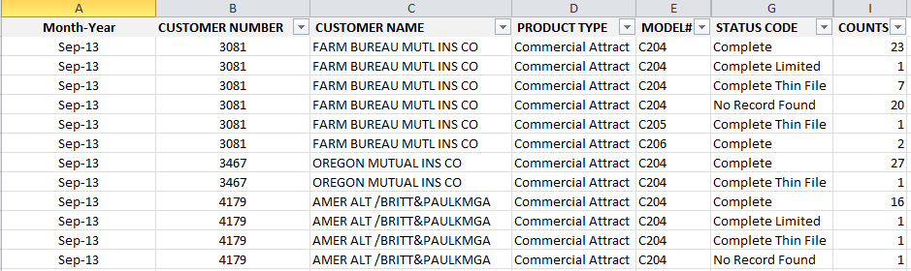

1. Consumer Disclosure – NA
2. Billing

Standard Transactional Billing – 2 Report Codes

* 1. Billing Type - Transactional
  2. Billing for this product should be included with all insurance products on one bill.
  3. Fulfillment/Finance has been approved
  4. Report Codes – 2

(Is this true? Vertical, will MVR still bill and we bill additionally for the model score?

– TBD-NPE will send request

* 1. Special Requirements – N/A

1. Testing
2. QC
3. MOE
4. Legal
   1. Legal approval has been obtained – Yes
5. Security Assessment
   1. Security/PSCO approval has been obtained – #2371506
6. Sales Tax – TBD – NPE to submit request

|  |  |  |
| --- | --- | --- |
|  | **Questions for Assessing Taxability of product/service** | **Response** |
| 1 | What company / legal entity is selling the product/service? |  |
| 2 | What is it exactly that we are selling?  Identify if there is a web site that has additional background information. |  |
| 3 | Are we selling this product/service to an end user or is it being resold? |  |
| 4 | Who are the customers? |  |
| 5 | Is the product/service in an electronic or print format? |  |
| 6 | What is the medium of transmission ( i.e. is the product/service shipped on a disk, e-mailed, load and leave, electronically transmitted, or accessed via software or a through a website)? |  |
| 7 | Is a software license being granted (i.e. a license to use computer software or the right to use and access computer software via software as a service model?) |  |
| 8 | Who initiates the transmission of the product/service? |  |
| 9 | Do we send the product/service to the customer or does the customer retrieve it? |  |
| 10 | Is there any tangible personal property associated with the sale of this product/service? |  |
| 11 | How do we bill for this product/service?  Is this a bundled charge or do we charge separately for different features of the product/service? |  |
| 12 | If the product/service includes data or information, is it personal and individual in nature such that no other customer can use the information? |  |
| 13 | Does this product/service generate any reports or files which can be used by other customers? |  |
| 14 | If there is a transmission of software or access to software via internet, is it canned or customized? |  |
| 15 | Can we obtain sample invoices or contracts? |  |
| 16 | Is this product shipped to or used in specific jurisdictions? |  |
| 17 | Is this product / service used in multiple jurisdictions and if so, can we obtain a breakdown of the use in each jurisdiction? |  |
| 18 | If the product is shipped, what are the terms of shipment?  Is a common carrier used?  Are goods dropped shipped? |  |
| 19 | Is there a maintenance component to the sale?  If so, is it mandatory or optional? |  |
| 20 | Are the different maintenance components separately stated on the customer invoices? |  |
| 21 | What is the delivery method, load and leave, electronic, or TPP?  What does the customer receive via the maintenance component? (i.e. phone support, email support, computer software upgrades, etc.?) |  |
| 22 | If the customer receives computer software upgrades, how are the upgrades provided (i.e. via diskette, emailed, downloaded, access through a website?) |  |
| 23 | Who is the product champion that would be the best contact for additional information? |  |
| 24 | What is the timeframe for rollout? |  |
| 25 | Is this an entirely new product/service or is this a subsequent phase of an existing product/service?  Will there be additional phases that need to be considered? |  |

**Appendices** –

1. Appendix A – Rules Functional Specifications - TBD
2. Appendix B – MBSi Screens - TBD

24. Appendix C – Model Document

1. Appendix C – Model Document – 2nd version

**Attract For Commercial Drivers Underwriting**

**Non-FCRA**

**(QB #1483)**

**Business Overview**

For the purposes of rating, Commercial insurers who write small to mid-size fleets traditionally collect detailed information related to the vehicles in the fleet. They procure information such the number of power units, gross vehicle weight (GVW), VIN, radius of operation, the use of the vehicles, and the three-year loss experience of the fleet. For many insurers, limited driver information such as years of experience, years employed, and age are used in policy rating. Insurers also pull MVR’s on individual drivers and charge for violations and accidents.

In a manner similar to private passenger auto rating, Commercial insurers desire to gather more detailed information on fleet drivers. This includes driver class (age, gender, and marital status), violation and accident history, credit, and other personal attributes predictive of the risk of loss. Ideally, they want to obtain this information in a cost effective manner and through a process that circumvents FCRA regulations. Due to FCRA considerations, it is not a common practice for insurers to order credit-based insurance scores for individual drivers to evaluate fleet risks. However, the need to evaluate each driver’s performance with credit-like attributes exists in the marketplace.

**Solution Description**

The LexisNexis solution will utilize non-FCRA Public Record, MVR, and Length of Driving Experience attributes that are predictive of individual loss experience to develop a score for each driver in a given fleet. Generalized Linear Modeling (GLM) techniques have been used to build the models. The models will provide a score and high-level model indicators for each driver (the model indicators need to be explored with carriers and Legal to determine if and what kind of additional detail should be returned). This new information, combined with other traditional rating variables already used by the carrier, will enable Commercial insurers to make better underwriting and pricing decisions thus enhancing profitability and mitigating risk.

Two versions of the model have been built. The first version uses Non-FCRA Public Records, Length of Driving Experience, and MVR violations and accidents. Additional non-FCRA data sources such as Commercial CLUE may be added at a later time pursuant to additional PIR requests. For commercial carriers who request this version of the model, we will provide it only to the extent that an MVR or Activity File (or CLUE Enhanced MVR) is ordered concurrently with the model score. In order to preserve the non-FCRA status of the model, the MVR or Activity File must be ordered directly through the state. At this time, the DUP & DHDB cannot be accessed as these databases are FCRA. However, a Non-FCRA MVR Retention Database is forthcoming in 2014.

The second version will exclude MVR attributes. Although MVR attributes add lift to the model, the second version is still very effective in rank ordering risky drivers.

**Modeling Process**

* The target variable (Y) is the risk of loss associated with an individual driver. Historical losses extracted from CLUE Auto© merged with MVR history from the same time period are used as the targets.
* The target data emanates from two groups. Group 1 is comprised of individual commercial drivers (based on commercially endorsed driver’s licenses) extracted from DHDB with prior MVR violations & accidents.
* Group 2 is comprised of CLUE Enhanced MVR extracts from six commercial carriers. These drivers may or may not have commercially endorsed DL’s.
* The model attributes have been be appended to the records for each group. Using GLM, the modelers determined which attributes (independent variables) were most predictive of the CLUE enhanced MVR extracts (target). The resulting models were then trained and validated on the two groups using different time periods.

**Attract For Commercial Drivers Underwriting**

**Non-FCRA**

**Modeling Process-Continued**

* The first version of the model uses MVR violations & accidents, Public Records, and Length of Driving Experience attributes. The second version excludes MVR attributes.
* The resulting models were further validated on actual Commercial Fleet Auto policies provided by Baldwin (Group 3). The models are very effective in rank ordering the average number of claims per quintile, and are reasonably effective in rank ordering loss ratio. Both models are able to single out drivers with high loss ratios in the worst quintile. The first version of the model grouped nearly 25% of all risky drivers in decile 1, while the second model singled out nearly 20% in decile 1.
* In order to further validate and/or fine tune the models, the modeling team has requested additional carrier policy datasets consisting of commercial fleet drivers. The Vertical is actively trying to acquire this data from key clients.

**Attributes**

The following matrices display the Public Records, Length of Driver Experience, and MVR attributes that were most predictive of a risky driver. If no derogatory events are found for a given driver, the attributes listed under “Score Card One” will be used to develop the score. If one or more are found, the attributes listed under “Score Card Two” will be used to develop the score. The MVR attributes are utilized only in Version One of the model.



**Attract For Commercial Drivers Underwriting**

**Non-FCRA**

**Attributes – Continued**



**Required Input**

* The order from the customer will be the same as used to order an MVR.  The customer inquiry will need Data Enhancement (such as address) to obtain missing information needed for the order to public records.  Leveraging a process used to order CLUE Enhanced MVR’s, the LexID for each driver will be appended from the Insurance Header. From the LexID, the most probable address can be developed for each driver. If an MVR is ordered (Version 1), the address can be extracted from the MVR Wallet Data.
* The LexID for each driver will be used to append the appropriate attributes (depending on which version of model is used) to be consumed by the model to develop the score and model indicators.

**Attract For Commercial Drivers Underwriting**

**Non-FCRA**

**Output and Delivery**

* As mentioned above, the model will produce a score for each driver from 200 to 997, where 200 = highest (worst) risk, 997 = lowest (best) risk. The address for each driver can be returned and model indicators could be provided in the Vertical decides to display them. 998 & 999 are reserved for no-hits and no scores.
* A composite score for the fleet will *not be* provided.
* The output will be delivered to the customer via MVR or an XML format when processing system to system. When ordering an MVR and the Score, the Score will be distinct from the MVR Report. For the purposes of POC (Proof of Concept), we will need the ability to process Retrospective Analyses. The Record Layout for this Analysis will be defined in a separate document.

**Contributory Requirements**

N/A

**Billing Requirements**

The Score is ordered either in addition to an MVR or in lieu of an MVR.

* MVR will generate a billing entry
* SCORE will generate its own billing entry

**QuickBase#1483**

Click [here](https://seisint.quickbase.com/db/be98uq7uq?a=dr&r=bqm) to see this Project Record within QuickBase (if you have permission).